Kevin Gilds, MPA

kevingilds@gmail.com

Abstract

Girl Scout Councils have nearly met their enrollment goals and are serving on average over 100 students a month at over 20 different locations. Survey data indicates students are starting from a lower skill baseline than in previous years.

Formative Evaluation

Get REAL! Program January 15, 2017

# Introduction

The Get REAL! program is a statewide mentoring program facilitated by six Girl Scout Councils in Florida. The goal of the Get REAL! program is to help at-risk middle school girls achieve academic success by connecting them to caring mentors in the community. Girl Scout facilitators and mentors deliver the Get REAL! program which includes a literacy component, character building, educational enhancement experience, and community service. The purpose of this report is to provide a detailed summary of the program; identify progress towards achieving objectives and provide recommendations for program improvement.

## Program Operation

Each Girl Scout Council collaborates with school officials to identify girls that would benefit from the Get REAL! program. Referrals come to the Get REAL! staff from school personnel and appropriate referrals for Get REAL! are at-risk girls based on (but not limited to) one or more of the following criteria:

* Enrolled in the 6th to 8th grade
* Are one or more grade levels behind in school;
* Who scored at Level 1 or Level 11 in FSA Reading;
* Have high absenteeism, or high disciplinary referrals;
* Struggling socially/family problems.

Student recruitment activities included meeting with school officials, word of mouth recruitment, announcement at school assemblies, visiting after-school programs, and sample sessions for mentees. The enrollment goal of the Get REAL! program was to serve 900 students by the end of the 4th Quarter. The Girl Scouts Councils are on target to reach their goal by serving 808 students as of December 31, 2016. Below is a map that shows the coverage and enrollment numbers for students in the Get REAL! program across Florida.

|  |  |  |  |  |
| --- | --- | --- | --- | --- |
| council | Sixth | Seventh | Eight | Total |
| Citrus Council | 48 | 39 | 14 | 101 |
| Gateway Council | 110 | 90 | 72 | 272 |
| Panhandle Council | 29 | 6 | 2 | 37 |
| Southeast Council | 21 | 24 | 16 | 61 |
| Tropical Council | 23 | 30 | 37 | 90 |
| West Central Council | 85 | 74 | 90 | 249 |

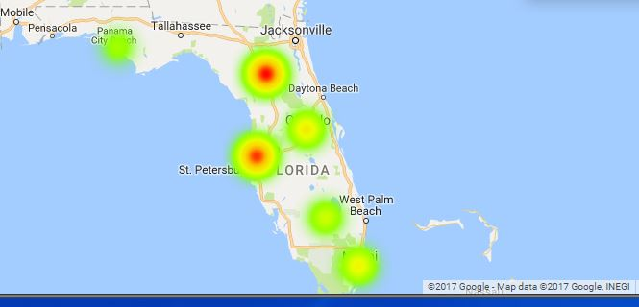

council_enrollment

## Attendance Data

The Get REAL! program is being offered on a consistent basis at over 20 locations across Florida. The number of mentoring sessions from October through December is 373 and the councils were averaging over 20 mentoring sessions a month. Students in the program are attending on a regular basis as evidenced by monthly attendance reports. Review of attendance reports demonstrates that the Girl Scout Councils are serving on average over 100 students every month since October 2016.

## Staff Quality

All program staff and mentors are personally interviewed, complete an Affidavit of Good Moral Character, submit to a reference check, and must satisfactorily pass a criminal background check to begin working with students. Upon successful completion of the application process, new staff and mentors receive training on the approved program curriculum, and safety standards. Trainings that must be completed by new staff and mentors include Girl Scouts 101, CPR/First Aid, Diversity, and Team Building.

## Mentor Recruitment

The Girl Scout Councils have recruited and trained a total of 55 individuals to be mentors and the mentors logged 708 hours to assist students in the program thus far. The goal of the Get REAL! program was to recruit enough mentors to maintain a 15-1 student-mentor relationship. Successful mentor recruitment has varied from council to council. One recruitment method for mentors was to present the positive outcomes of the Get REAL! program to prospects, and another method was to assigned certain students in the program to recruit prospective mentors.

## Program Components

The education literature has shown that students who are engaged in school achieve better educational outcomes such as higher grades and greater achievement on standardized tests (Fredricks et al. 2011). In contrast, students who are disengaged are at a higher risk for dropping out of school. Student engagement is multiple dimensional including behavioral engagement, emotional engagement, and cognitive engagement (Fredricks et al. 2011) Behavioral engagement consists a student's participation in school activities, emotional engagement refers to the connections and interactions a student has with peers and teachers, and cognitive engagement refers to resilience and the hard work required to be successful at school (Fredricks et al. 2011)

The program components of the Get REAL! program address the multiple facets of student engagement through a literacy program, character building, educational enhancements and community service opportunities. Facilitators and mentors work together to establish relationships with at-risk students and provide opportunities for educational enhancement trips and community services. The program components and activities of the Councils will be discussed in this section.

### Literacy Component:

The reading portion of the Get REAL! program uses the See Girls Read! curriculum, and girls read at least five books during the 30-session program. As part of the Girl Scout process, students are given input about what books they wish to read. Mentors facilitate discussion about the books the girls are reading, and participants read and write in their journal. The group discussions and writing activities help increase emotional and cognitive engagement in the students. Periodically the girls are encouraged to share their journals with their mentor and the mentor will respond to them. Journaling gives girls additional writing experience and helps establish connections with their mentor.

A list of books read thus far by students in the Get REAL! program:

*Pinned*

*You don't even know me*

*Who am I without him*

*Allegiant*

*Crossover*

*Girl Power*

*Crossing Jordan*

*Wonder*

*The Girls*

*Speak*

### Character Building/Life Skills

Relationships and connections with peers and teachers plays a critical role in academic engagement for students (Fredricks et al. 2011). All Girl Scout councils utilize the modules "Being a Girl", "Friendship" and "Body Image" from the Girls Circle curriculum. The modules focus on self-esteem, social development and interpersonal relationships to help the students solidify relationships with themselves, peers, and teachers.

### Educational Enhancements

Girls in the Get REAL! program participate in educational enhancements that consists of out-of-school learning experiences which include camp visits, legislative day and half-day trips to local educational facilities. Examples of the educational enhancement opportunities planned for this year include the following:

* Bricks 4 Kidz a S.T.E.M program that also includes financial literacy
* Outing to Camp Mah Kah Wee for team-building activities using an obstacle course
* Non traditional career fair featuring non traditional careers for women

### Community Care Projects

An important part of Girl Scouting is community care projects to help girls identify what they can do to help their community. Community care projects give the students opportunities to identify problems and work together to make a plan to help solve that problem. Each program group develops their own projects that is specific to their community. Community Care Projects planned for this year include

* Creating blankets for local homeless shelter
* Donation Drive for the Victims of Hurricane Matthew. Students developed flyers and engaged with school and community to assist as well

# Objective Assessment: Data analysis and indication of progress towards achieving each objective

## Life Skills

*Objective --70% of participating girls will demonstrate an increased understanding of pertinent life skills as demonstrated by a pre and post assessment.*

The survey administered to the students measures the following life skills, healthy relationships, academic engagement, and academic mastery.

• Healthy Relationships--Measures relationship skills with peers and adults.

• Academic Engagement--Measures specific behaviors related to school success.

• Academic Mastery--Measures attitude toward education.

The questions and the scoring methodology of the girl survey were developed and tested by the Girl Scout Research Institute. Girls answer multiple questions to obtain an outcome score for each life skill domain. Responses to survey questions are assigned numbers/points and outcome scores are calculated by averaging responses to survey questions for each category. The points for each outcome set are averaged to obtain an outcome score. Outcome cutpoints are determined by the number of questions in the outcome set and response options.

Outcomes scores range from 0-6. Below is a breakdown of the cut-points by the outcomes measured. Outcome cut-points are used to determine high achievement. Below is a breakdown of the cutpoints by the outcomes measured.

### Cutpoints

|  |  |
| --- | --- |
| Outcome | criteria |
| Healthy Relationships | 4.45 |
| Academic Mastery | 4.8 |
| Academic Engagement | 4.5 |

### Pre-Survey and Quarter 1 Academic Data Results

The analysis below breaks down the pre-survey results by life skills outcome including cross validation of parent and teacher pre-surveys. The analysis below also provides baseline data of Quarter 1 academic and school behavior data. The parent and teacher survey support evidence from the student surveys.

# Healthy Relationship Outcome

Relationship skills are a critical component of success in all realms of life. The healthy relationship questions measures the behaviors and attitudes of the respondent regarding their relationship skills. Questions that measure healthy relationships skills include the following:

*Healthy Relationship Questions*

1. If I have a serious problem, I have people to talk with.
2. I let people know if they have hurt my feelings.
3. I let my friends know when I think they are good at something.
4. In any relationship - romantic or not - I make it clear when I don't feel comfortable.

## Pre-Survey Analysis

The number of valid surveys entered is **633**, and the number of students achieving at a high level is **245** and that equates to **38.7%**. The average score from students is **3.9**

### Healthy Releationship: Pre Outcome Score Summary

|  |  |  |  |  |  |
| --- | --- | --- | --- | --- | --- |
| Min. | 1st Qu. | Median | Mean | 3rd Qu. | Max. |
| 0 | 3.15 | 3.9 | 3.899 | 4.875 | 6 |

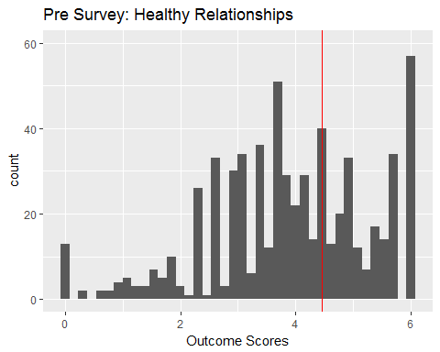

# Pre Survey: Healthy Relationship History

|  |  |  |  |
| --- | --- | --- | --- |
| Year | population | percent_achieved | mean |
| 2013 | 699 | 61% | 4.55 |
| 2014 | 1186 | 61% | 4.44 |
| 2015 | 844 | 59% | 4.41 |

## Cross Validation of Healthy Relationship Skills

Survey results from teachers and parents also provide useful baseline data to gauge life skills. Below are tables and graphs that provide a breakdown of questions on the pre survey from the parent and teacher surveys.

### Pre Parent Survey

**Question 5: She develops positive relationships with her classmates.** N=520

Item low neutral high mean sd  
 Q5 7.307692 19.42308 73.26923 5.25 1.33249

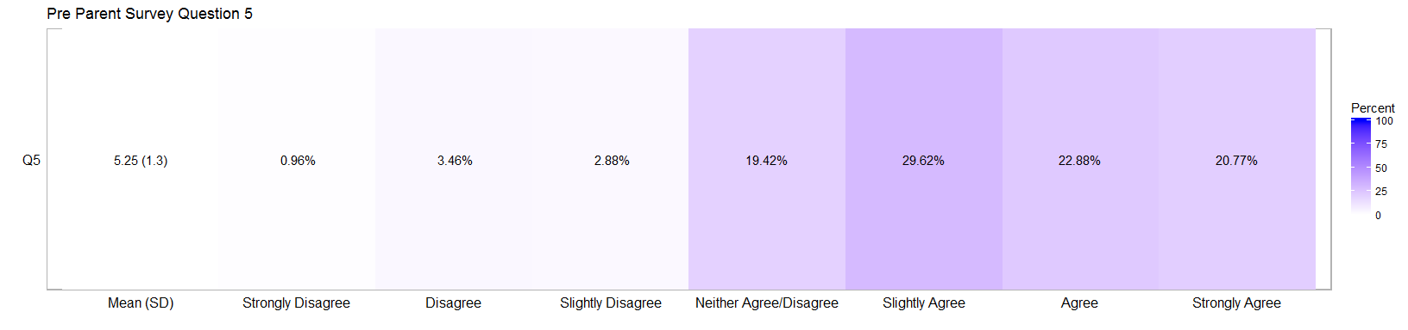

### Teacher Survey

**Question 7: She has developed positive relationships with her classmates.** N=360

Item low neutral high mean sd  
 Q7 10.55556 27.77778 61.66667 4.925 1.315194

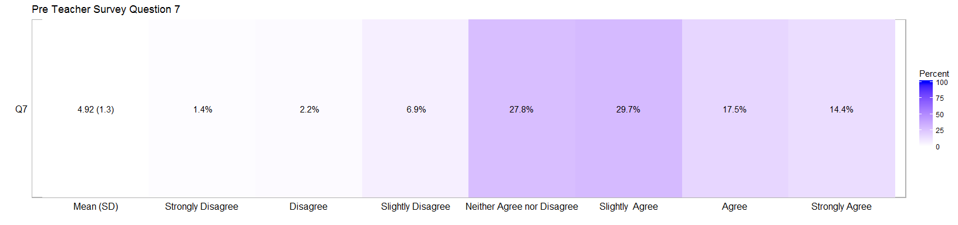

### Healthy Relationship Analysis

The pre-survey result indicates that the students in the program do not have strong relationship skills as compared to students in past years and this is a potential growth area for the students. Typically, 61 percent of the students come into this program with strong healthy relationship skills whereas this year it was under 40 percent.

Results from the parent and teacher surveys are trending with the student survey. Nearly three-quarters of parents indicated high agreement that their child had positive relationship at school. Although this may seem strong, this is a 10 percent decrease from the pre-survey last year. Nearly two-thirds of teachers have a high agreement that the students have developed positive relationships.

Reviewing the distribution of pre-surveys scores indicates that 172 students are between 3.45 and the 4.45 cutpoint. The Get REAL! program has been strong in developing the healthy relationship outcome skill in past years. Last year 26 percent of students improved from a low skill level to a high skill level and over 85 percent had success with this outcome.

# Academic Engagement Outcome

Academic engagement questions gauge tangible behaviors that help students succeed in school. Questions that measure academic engagement include the following.

**Academic Engagement Questions**

1. I talk with my teachers before or after school, or during lunch about my assignments.
2. I hand in my assignments on time
3. I finish my homework even if it is boring
4. If I can't understand my schoolwork at first, I keep trying until I do understand it.

## Pre-Survey Analysis

The number of valid surveys entered is **633**, and the number of students achieving at a high level is **194** and that equates to **19.91%**. The average score from students is **3.66.**

### Academic Engagement: Pre-Outcome Score Summary

|  |  |  |  |  |  |
| --- | --- | --- | --- | --- | --- |
| Min. | 1st Qu. | Median | Mean | 3rd Qu. | Max. |
| 0 | 3 | 3.75 | 3.663 | 4.5 | 6 |

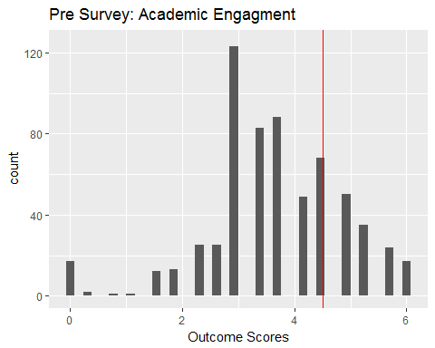

# Pre Survey: Academic Engagement History

|  |  |  |  |
| --- | --- | --- | --- |
| Year | population | percent_achieved | mean |
| 2013 | 699 | 46.92% | 4.1 |
| 2014 | 1186 | 40.05% | 3.82 |
| 2015 | 642 | 40.46% | 4.24 |

## Cross Validation of Academic Engagement Skills

Survey results from teachers and parents also provide useful baseline data to gauge life skills. Below are tables and graphs that provide a breakdown of questions on the pre survey from the parent and teacher surveys.

### Pre Parent Survey

**Question 6: She works on her homework at home without supervision.** N=520

Item low neutral high mean sd  
 Q6 3.653846 16.73077 79.61538 5.592308 1.261226

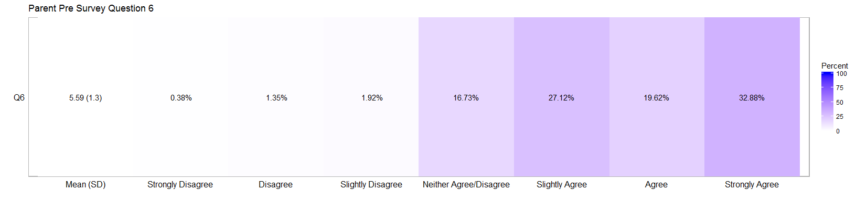

### Teacher Survey

**Question 5: She positively participates in class.** N= 360

**Question 6: She completes the homework given to her.** N= 360

Item low neutral high mean sd  
 Q6 10.58496 27.29805 62.11699 4.955432 1.298137  
 Q5 12.77778 32.22222 55.00000 4.733333 1.350126

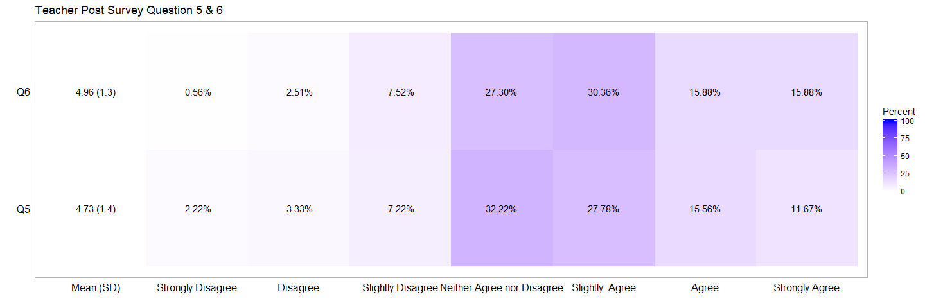

### Analysis Academic Engagement

Students in the Get REAL! program typically do not come into the program with a high academic engagement scores. This year is no different but the outcomes scores are much lower than expected. Typically, around 40 percent of students come to the program with solid academic behaviors but this year it was 20 percent.

Parent and teacher pre-surveys support evidence from the students’ surveys. Nearly two-thirds of teachers indicate that the students positively participate in class. A little more than half of teachers agreed that the students completes homework given to her. More than three-quarters of parents had high agreement that their child does school work without supervision. However, this is nearly a 10 percent decrease from the pre-survey results last year.

This life skill outcome presents another growth opportunity for the students. Reviewing the outcome distribution 137 students are between 3.45 and the cutpoint for achieving this outcome at a high level. Last year 80 percent of students had a positive outcome, and a quarter of the students went from low achievement to high achievement.

# Academic Mastery Outcome

Academic mastery questions gauge a student's attitude towards school and education. Questions that measure academic mastery include the following.

* It's important to me that I improve my skills this year in school
* It's important to me that I really understand my class work
* Learning at school is important to me
* One of my goals in school is to learn as much as I can
* The things I am learning in school will help me later in life

## Pre-Survey Analysis

The number of valid surveys entered is **633**, and the number of students achieving at a high level is **333** and that equates to **52.61%**. The average score from students is **4.51.**

### Academic Mastery: Pre-Outcome Summary

|  |  |  |  |  |  |
| --- | --- | --- | --- | --- | --- |
| Min. | 1st Qu. | Median | Mean | 3rd Qu. | Max. |
| 0 | 3.6 | 4.8 | 4.508 | 5.76 | 6 |

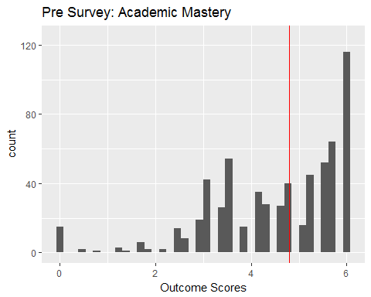

# Pre Survey: Academic Mastery History

|  |  |  |  |
| --- | --- | --- | --- |
| Year | population | percent_achieved | mean |
| 2013 | 699 | 85.98% | 5.38 |
| 2014 | 1186 | 76.98% | 5.12 |
| 2015 | 642 | 74.76% | 5.14 |

## Cross Validation of Academic Mastery

Survey results from teachers and parents also provide useful baseline data to gauge life skills. Below are tables and graphs that provide a breakdown of questions on the pre survey from the parent and teacher surveys.

## Pre Parent Survey

**Question 1: She is motivated to graduate high school.** N=520

**Question 3: She has a Good Attitude About School.** N=520

Item low neutral high mean sd  
 Q1 1.153846 17.50000 81.34615 5.888462 1.201741  
 Q3 2.500000 17.88462 79.61538 5.648077 1.202597

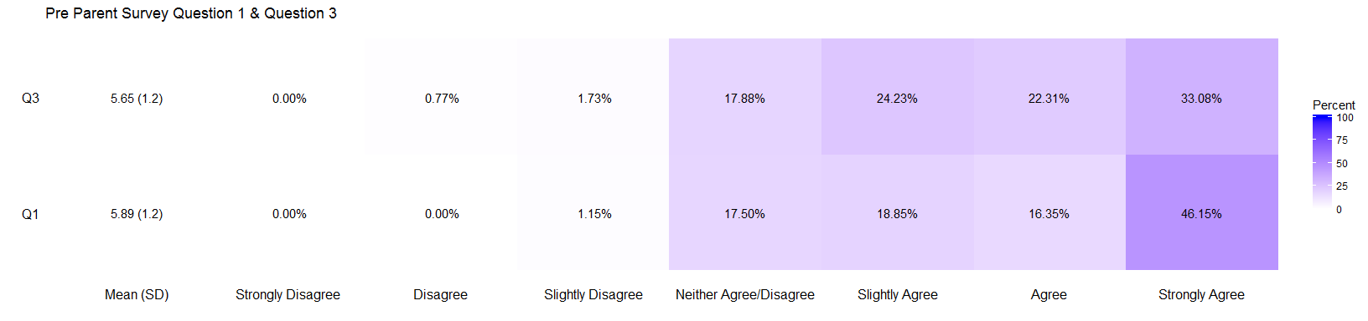

### Teacher Pre Survey

**Question 1: She is motivated to graduate high school.** N=360

**Question 3: She has a Good Attitude About School.** N=360

Item low neutral high mean sd  
 Q1 7.50000 37.22222 55.27778 4.969444 1.308494  
 Q3 10.27778 36.66667 53.05556 4.861111 1.348739

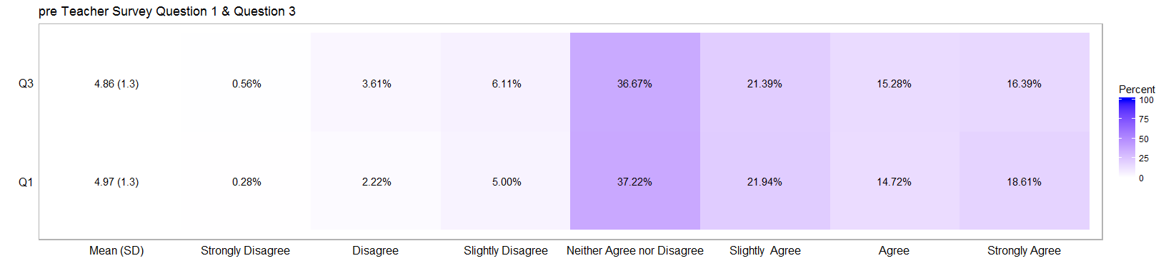

### Analysis Academic Mastery

The pre-survey results indicate that the students have a moderately positive attitude towards education. However, students typically come into the program with a much better attitude towards education and school. Currently just over half of the students have a positive attitude toward school whereas at least 70 percent of students would come into the program with a positive attitude.

Results from the parent and teacher surveys are trending with the student survey. Results from the teacher survey are more cautious in their agreement that the student has a good attitude towards education and motivation to graduate with about 55 percent in agreement. Parent surveys indicate a high level of agreement that the student has a positive attitude toward school and is motivated to graduate high school with 80 percent in agreement. However, this is about a 10 percent decrease in level of agreement from last year.

The academic mastery life skill will be an interesting data point to follow. If attitudes toward education changes will other life skill outcomes will improve and will academic behavior be impacted? Currently 105 students have an outcome score that ranges from 3.8 to the cutpoint of 4.8. Academic mastery is a foundation for other life skills and outcomes.

# Reading Improvement

*Objective: 50% of participating students will improve their reading skills as demonstrated by their Language Arts grade increasing or maintaining a “C” grade from the baseline grading period to the final grading period as evidenced by report cards/school reports.*

The number of valid data entries is **544**. Students in the Get REAL! program are off to a good to start as 88 percent of the students have a C or higher in their Language Arts course. However, it would be advisable to monitor grades closely as students are likely to regress over the 2nd quarter.

Q1 Grades

|  |  |  |  |  |  |
| --- | --- | --- | --- | --- | --- |
|  | A | B | C | D | F |
| **16-17** | 139 | 178 | 159 | 58 | 10 |

Q1:Language Arts Courses and Grades

|  |  |  |  |  |  |
| --- | --- | --- | --- | --- | --- |
|  | A | B | C | D | F |
| **ENGLISH** | 0 | 1 | 1 | 0 | 0 |
| **M/J LANG ARTS 1** | 31 | 54 | 42 | 22 | 2 |
| **M/J LANG ARTS 1 ADV** | 21 | 10 | 2 | 1 | 0 |
| **M/J LANG ARTS 2** | 21 | 51 | 62 | 20 | 6 |
| **M/J LANG ARTS 2 ADV** | 29 | 9 | 5 | 0 | 0 |
| **M/J LANG ARTS 2 ESOL** | 1 | 0 | 0 | 0 | 0 |
| **M/J LANG ARTS 3** | 15 | 40 | 45 | 15 | 2 |
| **M/J LANG ARTS 3 ADv** | 21 | 13 | 2 | 0 | 0 |

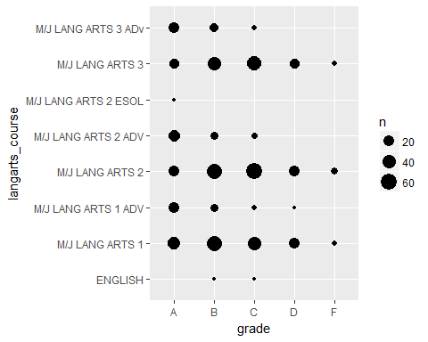

Grade Table History--Quarter 1

|  |  |  |  |  |  |
| --- | --- | --- | --- | --- | --- |
|  | A | B | C | D | F |
| **15-16** | 132 | 190 | 173 | 78 | 26 |
| **16-17** | 139 | 178 | 159 | 58 | 10 |

Quarter 1 GPA History

|  |  |
| --- | --- |
| Year | lang_avg |
| 15-16 | 2.540902 |
| 16-17 | 2.694853 |

The number of valid entries is **225** and 87 percent of the students have a C grade or higher in reading focused courses.

Grade Table History--Quarter 1

|  |  |  |  |  |  |
| --- | --- | --- | --- | --- | --- |
|  | A | B | C | D | F |
| **16-17** | 50 | 77 | 68 | 22 | 8 |

Q1:Reading Arts Courses and Grades

|  |  |  |  |  |  |
| --- | --- | --- | --- | --- | --- |
|  | A | B | C | D | F |
| **M/J INENS READ (MC)** | 5 | 3 | 2 | 4 | 0 |
| **M/J INTENS READ** | 17 | 28 | 17 | 11 | 1 |
| **M/J READ 1** | 1 | 12 | 14 | 2 | 2 |
| **M/J READ 1, ADV** | 4 | 4 | 3 | 0 | 1 |
| **M/J READ 2** | 3 | 11 | 23 | 4 | 2 |
| **M/J READ 2, ADV** | 7 | 7 | 2 | 0 | 1 |
| **M/J READ 3** | 5 | 8 | 7 | 1 | 0 |
| **M/J READ3, ADV** | 8 | 4 | 0 | 0 | 1 |

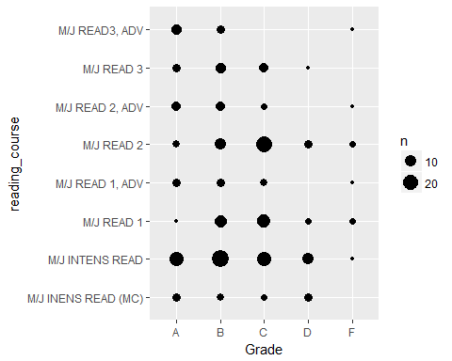

Grade Table History--Quarter 1

|  |  |  |  |  |  |
| --- | --- | --- | --- | --- | --- |
|  | A | B | C | D | F |
| **15-16** | 38 | 104 | 108 | 38 | 11 |
| **16-17** | 50 | 77 | 68 | 22 | 8 |

Quarter 1 GPA History

|  |  |
| --- | --- |
| Year | reading_avg |
| 15-16 | 2.401338 |
| 16-17 | 2.617778 |

# Decrease in Absenteeism

*Objective: 60% of participating students will either maintain or improve their attendance rates as demonstrated by their decreased absences from the baseline grading period to the final grading period as evidenced by report cards/school report*

The number of valid data entry records is **553**. The percent of students without an absence is **47.2%**. The percent of students with less than four absences is **78.66%** and the percent of students with four or more absences is **21.34%**. Students with more than 4 absences are at risk for chronic absenteeism if they maintain their rate of absences.

|  |  |  |  |  |  |  |  |  |  |  |  |  |  |  |  |  |  |
| --- | --- | --- | --- | --- | --- | --- | --- | --- | --- | --- | --- | --- | --- | --- | --- | --- | --- |
| 0 | 1 | 2 | 3 | 4 | 5 | 6 | 7 | 8 | 9 | 10 | 14 | 15 | 17 | 22 | 24 | 28 | 46 |
| 261 | 47 | 62 | 65 | 47 | 15 | 18 | 8 | 13 | 6 | 1 | 1 | 1 | 2 | 3 | 1 | 1 | 1 |

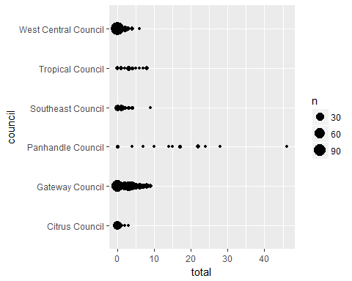

### Unexcused Absences:

|  |  |  |  |  |  |  |  |  |  |  |
| --- | --- | --- | --- | --- | --- | --- | --- | --- | --- | --- |
| 0 | 1 | 2 | 3 | 4 | 5 | 6 | 7 | 8 | 9 | 20 |
| 340 | 54 | 68 | 34 | 20 | 12 | 6 | 10 | 5 | 3 | 1 |

### Excused Absences:

|  |  |  |  |  |  |  |  |  |  |  |  |  |  |  |  |  |
| --- | --- | --- | --- | --- | --- | --- | --- | --- | --- | --- | --- | --- | --- | --- | --- | --- |
| 0 | 1 | 2 | 3 | 4 | 5 | 6 | 7 | 8 | 10 | 14 | 15 | 17 | 18 | 20 | 23 | 26 |
| 342 | 98 | 62 | 21 | 11 | 2 | 1 | 2 | 3 | 3 | 1 | 1 | 2 | 1 | 1 | 1 | 1 |

### Attendance Analysis

Attendance is vital for academic success and data has shown that being absent 10 percent of school days excused or unexcused places students in danger of negative outcomes such as dropping out of school (“PreventingMissedOpportunityFull_FINAL9.8.16_2.pdf” 2017). This analysis shows that a little over 20% of the students in the program are in danger of chronic absenteesim. Students with 4 or more absences in the first quarter could be labeled at risk for chronic absenteesim.

The Get REAL! program is designed to engage at risk students and provide incentives for attendance and positive behavior. Attendance rates of students should be monitored closely to intervene as quick as possible. Last year 54% of the students improved their attendance from baseline to final grading period.

# Improvement in School Behavior

*Objective: 70% of participating students will show improvement in behavior by decreasing their number of suspensions from the baseline grading period to final grading period or not having a suspension during the school year as evidenced from the student's report card/school reports.*

Baseline data indicates number of valid data entries is **553** and the percent of students who have not experienced a suspension as of Quarter 1 is **89.69%.**

|  |  |  |  |  |  |
| --- | --- | --- | --- | --- | --- |
| 0 | 1 | 2 | 3 | 4 | 5 |
| 496 | 21 | 16 | 7 | 6 | 7 |

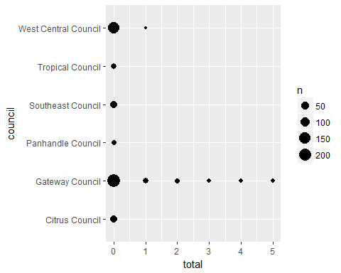

# Out of School Suspensions

|  |  |  |  |  |
| --- | --- | --- | --- | --- |
| 0 | 1 | 2 | 3 | 4 |
| 533 | 6 | 6 | 7 | 1 |

# In School Suspensions

|  |  |  |  |  |
| --- | --- | --- | --- | --- |
| 0 | 1 | 2 | 3 | 4 |
| 502 | 22 | 23 | 2 | 4 |

# Expelled

|  |
| --- |
| No |
| 553 |
|  |

### Behavior Analysis

Nearly 90 percent of students have not had any type of suspensions and no students was expelled. The Get REAL! program has a history of helping students improve their school related behaviors.

# Conclusion/Recommendations

The Get REAL! program has administered the same surveys for the past four years and for the past three years the responses have consistently told the story of students who valued education and wanted success but did not have all the tools to be successful. The Get REAL! program has had a history of successfully providing the tools to the at-risk students.

This group of students presents an opportunity for the Get REAL! program to show how it impacts at risk students as the pre-survey results indicate that this group of students may be more challenging than in past years. The results of the life skills survey indicate that this group of students is starting from a lower baseline than in previous years. Parent and teacher pre-surveys are also indicating a lower baseline level of life skills for students. However, 88 percent of the students currently have a grade of C or higher in their Language Arts course.

The Girl Scout councils are in a strong position to meet the objectives of the Get REAL! program. The councils have nearly met the enrollment goal of serving 900 students, and the Get REAL! program have a strong history of helping students achieve positive outcomes. The following are recommendations to help councils achieve the objectives of the program.

*Recommendation 1: Data entry for surveys and academic data*

Valid data entry is key toward assessing student progress and demonstrating the impact of the Get REAL! program. Reduce the gap between enrollment numbers and the surveys entered and grades entered. Status reports provide the number of valid entries and a spreadsheet file of duplicate data entry to be resolved in a Dropbox file.

* Administering and entering survey data into Qualtrics prior to June 1, 2016 and academic data by June 30, 2016. This data management practice will help identify and resolve and issues.
* Ensure all students in the program complete a pre-and post-survey and enter academic data. Records of data entry status is available to each council representative.

*Recommendation 2: Document educational interventions/trainings*

There is great documentation of higher level learning activities such as relationship skill building, educational enhancement, and community engagement but little reporting about how program staff and mentees impact students’ attendance, behavior outcomes, and grades. Ensure that you are capturing the stories and the informal interventions to help students succeed in school.

* Identify and document ways mentors and program staff provide educational support to the mentees such as study tips, test taking skills or other educational interventions. **This can be documented by way of stories and best practices not individual student data.**
* Identify and document ways mentors and program staff implement incentives for students to improve attendance, behavior and grades.

# References

Fredricks, Jennifer, Wendy McColskey, Jane Meli, Joy Mordica, Bianca Montrosse, and Kathleen Mooney. 2011. “Measuring Student Engagement in Upper Elemantary Through High School: A Description of 21 Instruments.” IES National Center for Education Evaluation and Regional Assistance.

“PreventingMissedOpportunityFull_FINAL9.8.16_2.pdf.” 2017. Accessed January 1. <http://www.attendanceworks.org/wordpress/wp-content/uploads/2016/08/PreventingMissedOpportunityFull_FINAL9.8.16_2.pdf>.